**SPRING REST USING SPRING BOOT 3**

**SPRING-REST-HANDSON**

**CREATE A SPRING WEB PROJECT USING MAVEN**

**SpringLearnApplication.java**

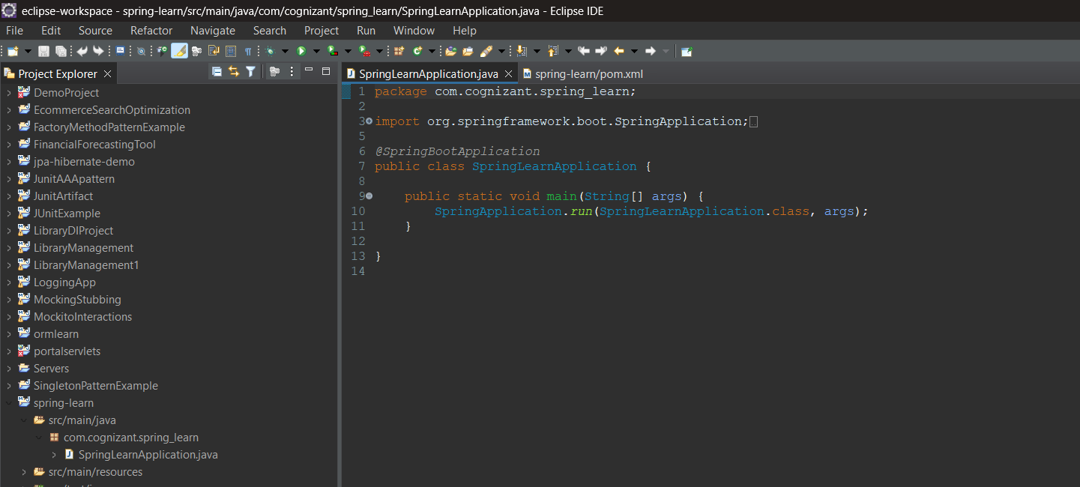

**Pom.xml**

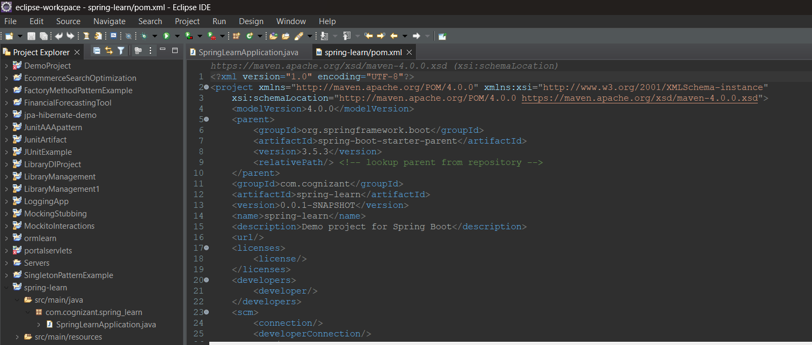

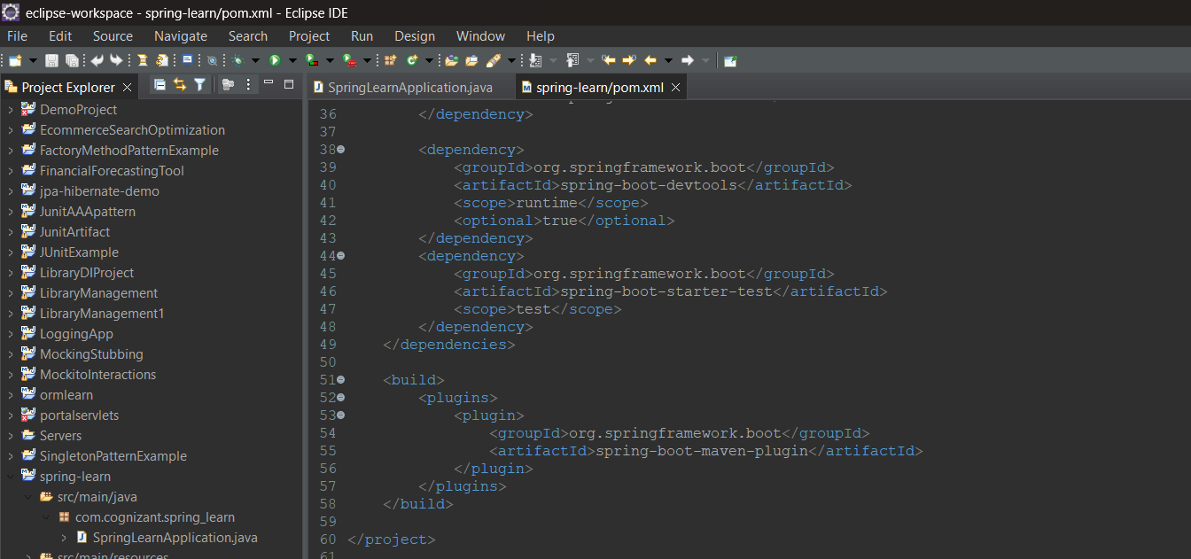

**Dependency Hierarchy**

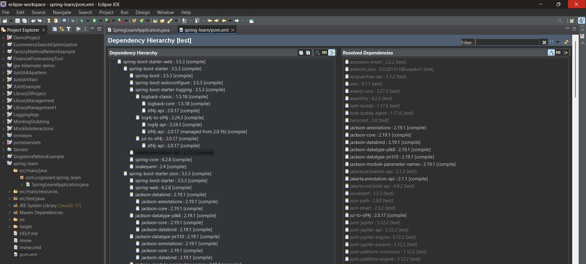

**Console**

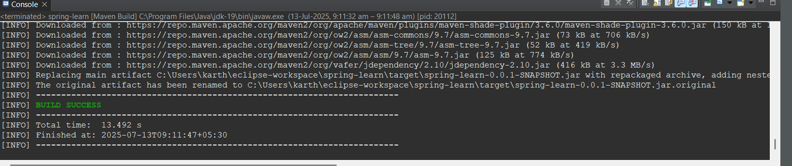

**SPRING CORE – LOAD COUNTRY FROM SPRING CONFIGURATION XML**

**Pom.xml**

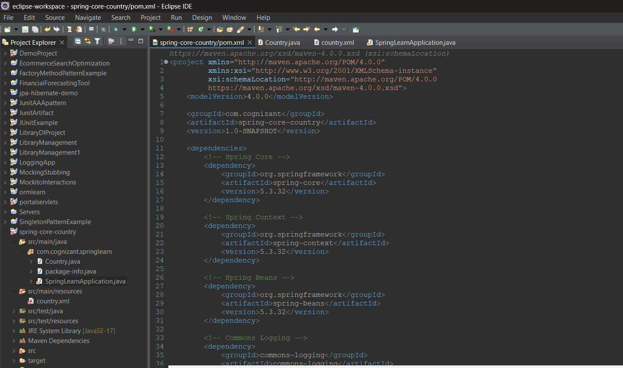

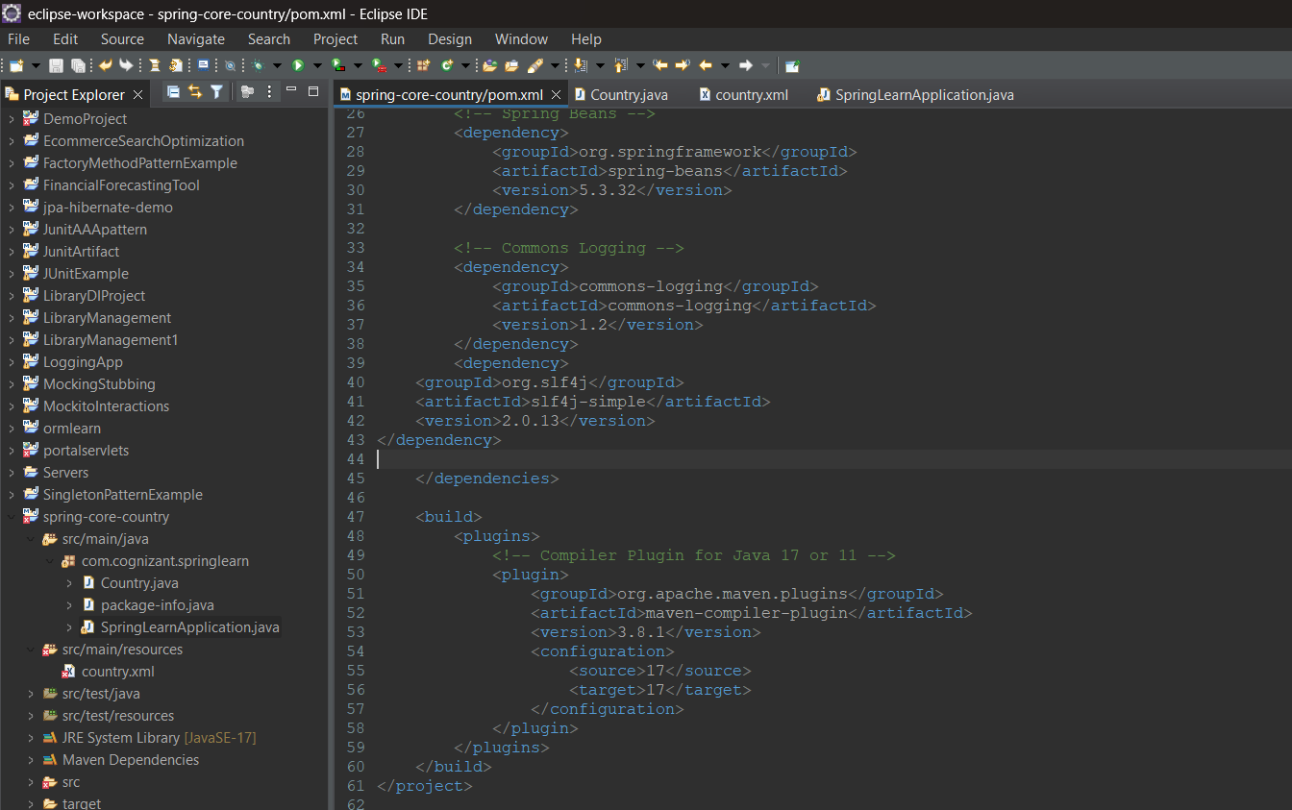

**Country.java**

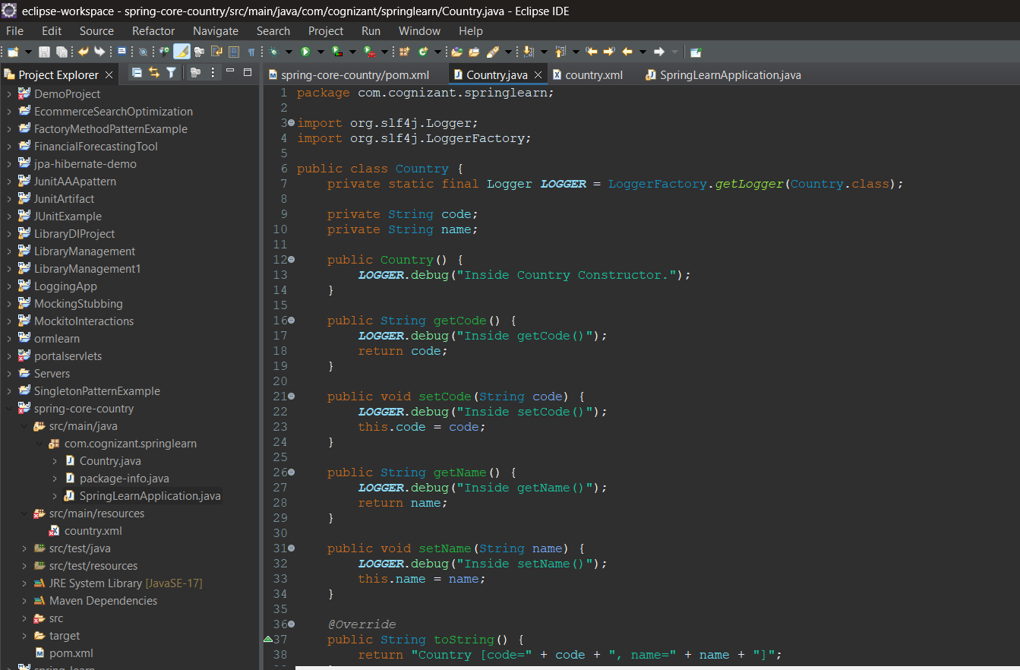

**Country.xml**

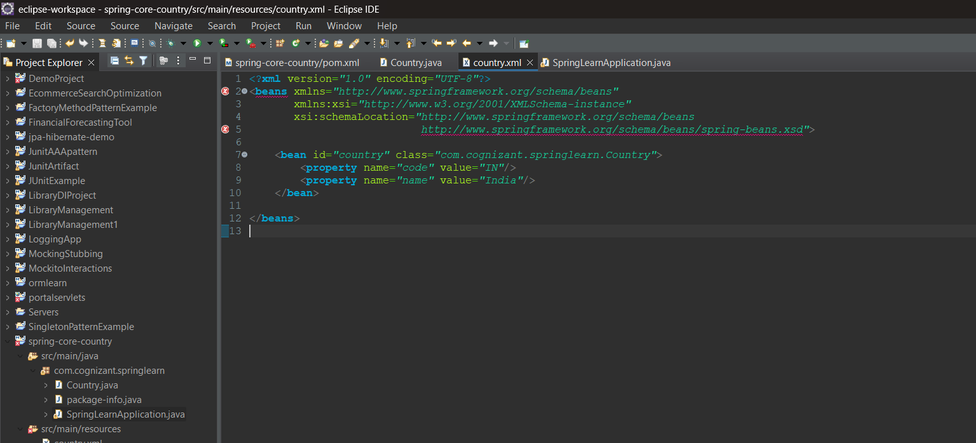

**SpringLearnApplication.java**

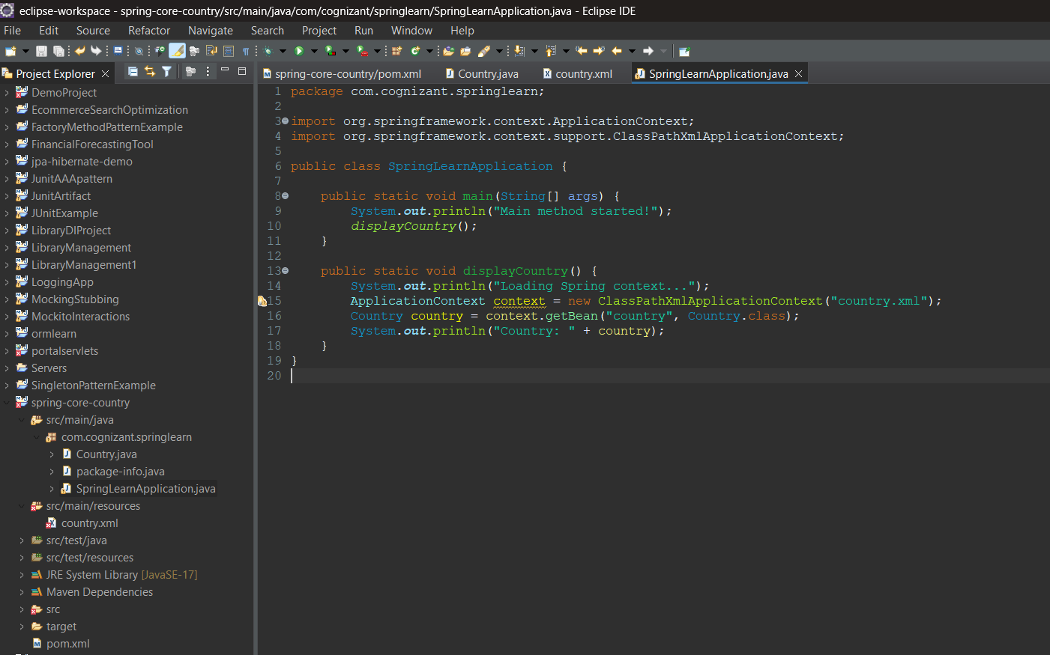

**Output**

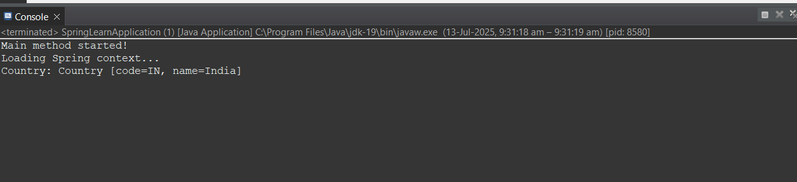

**HELLO WORLD RESTFUL WEB SERVICE**

**HelloController.java**

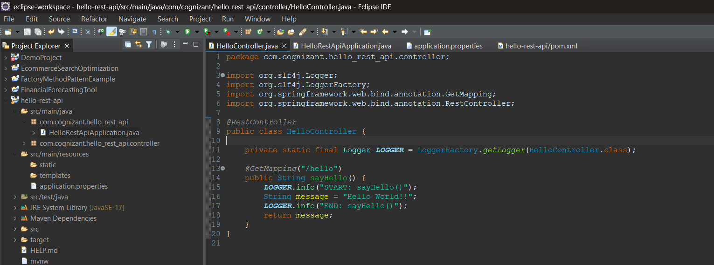

**HelloRestApiApplication.java**

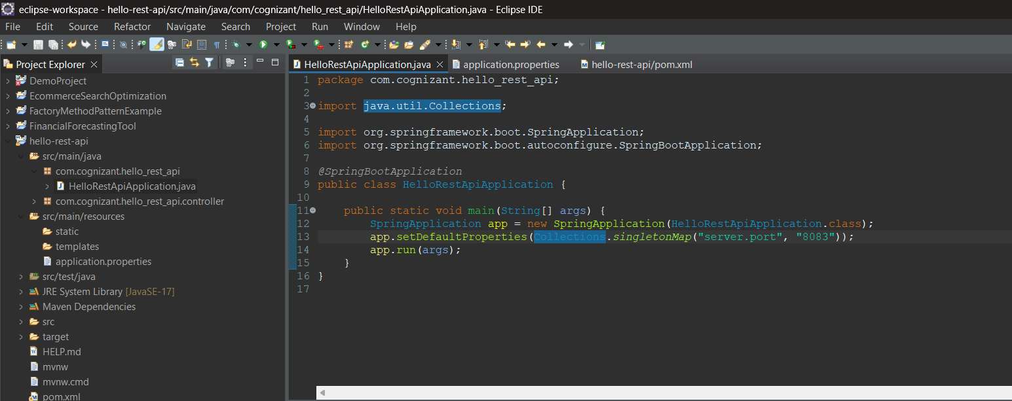

**Application.properties**

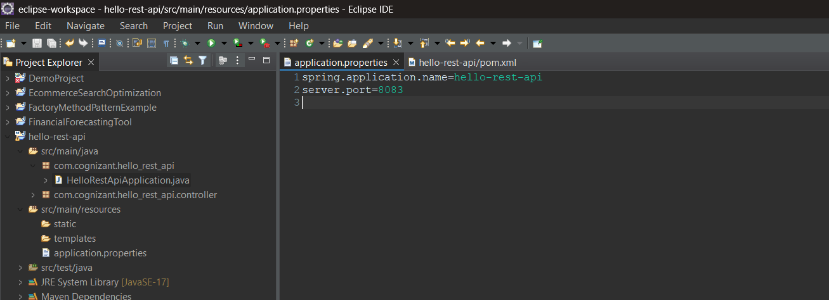

**Pom.xml**

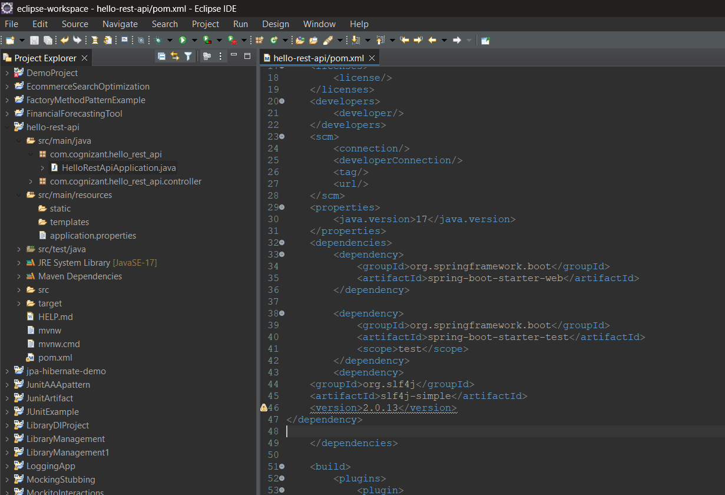**Console**

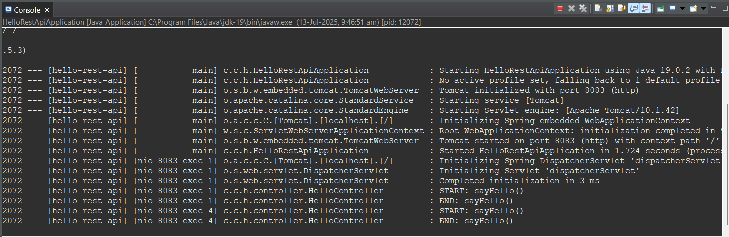

**Postman**

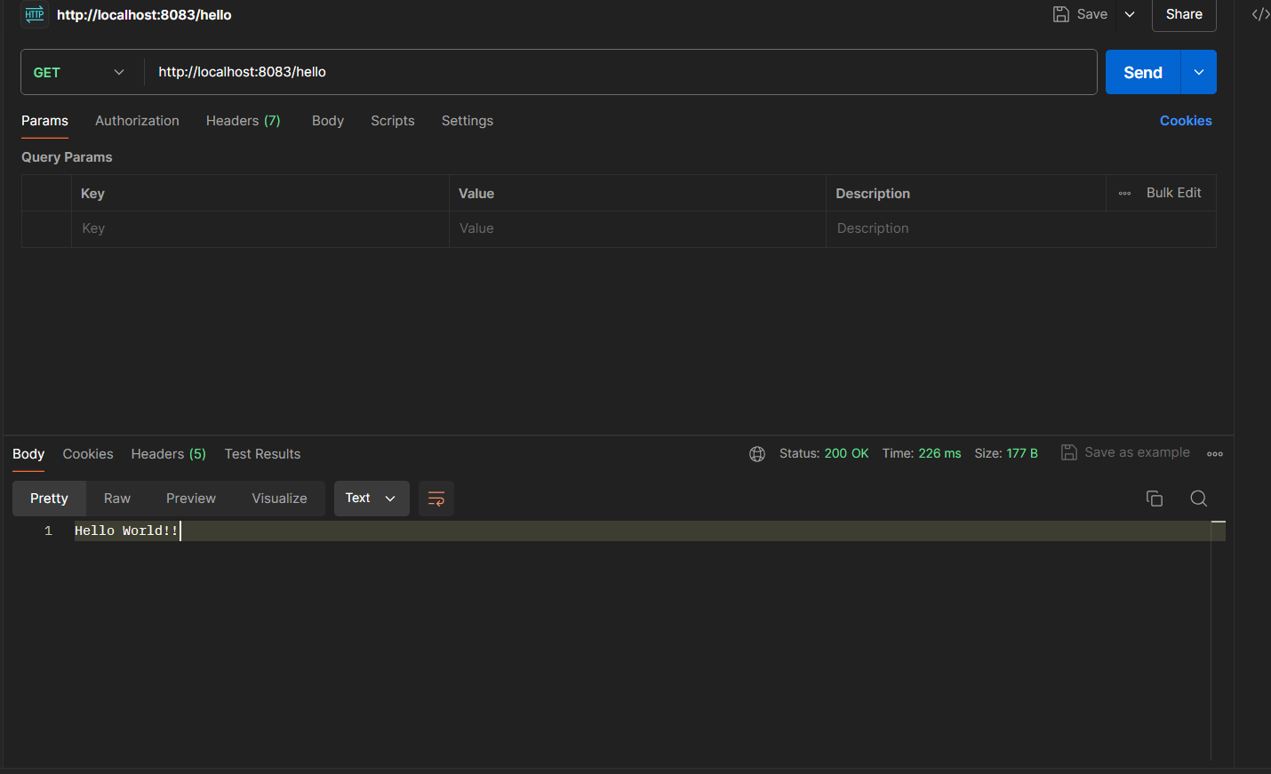

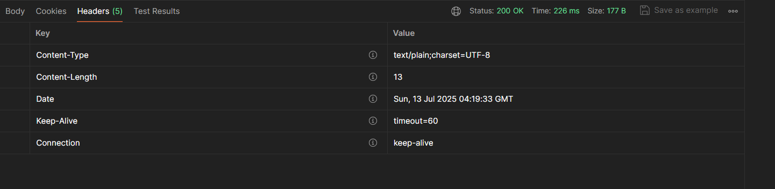

**Chrome**

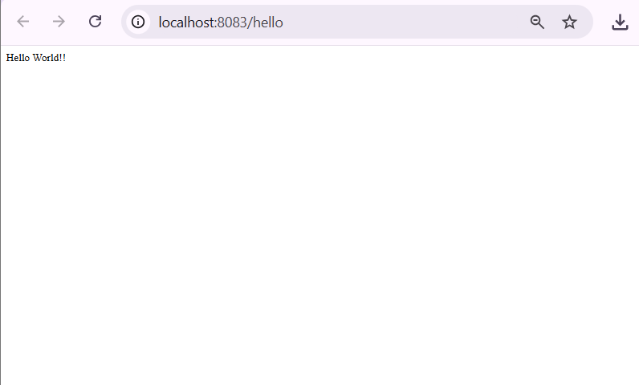

**REST - COUNTRY WEB SERVICE**

**Country.xml**

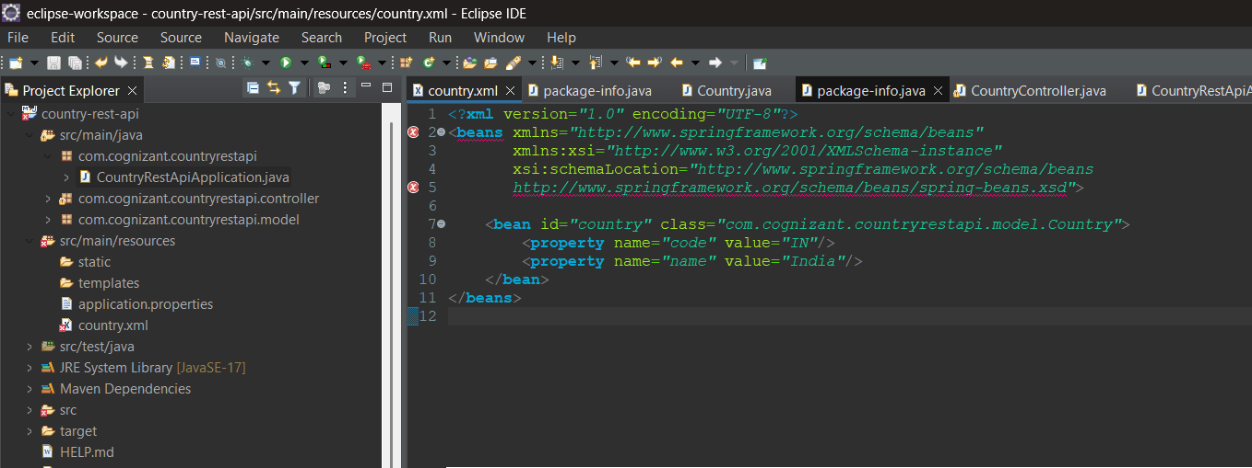

**CountryRestApiApplication.java**

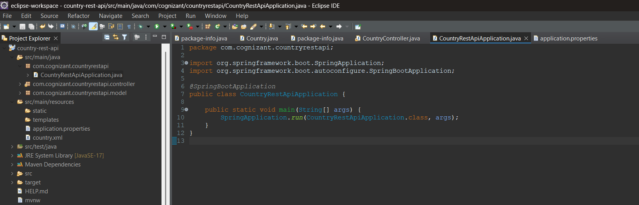

**Application.properties**

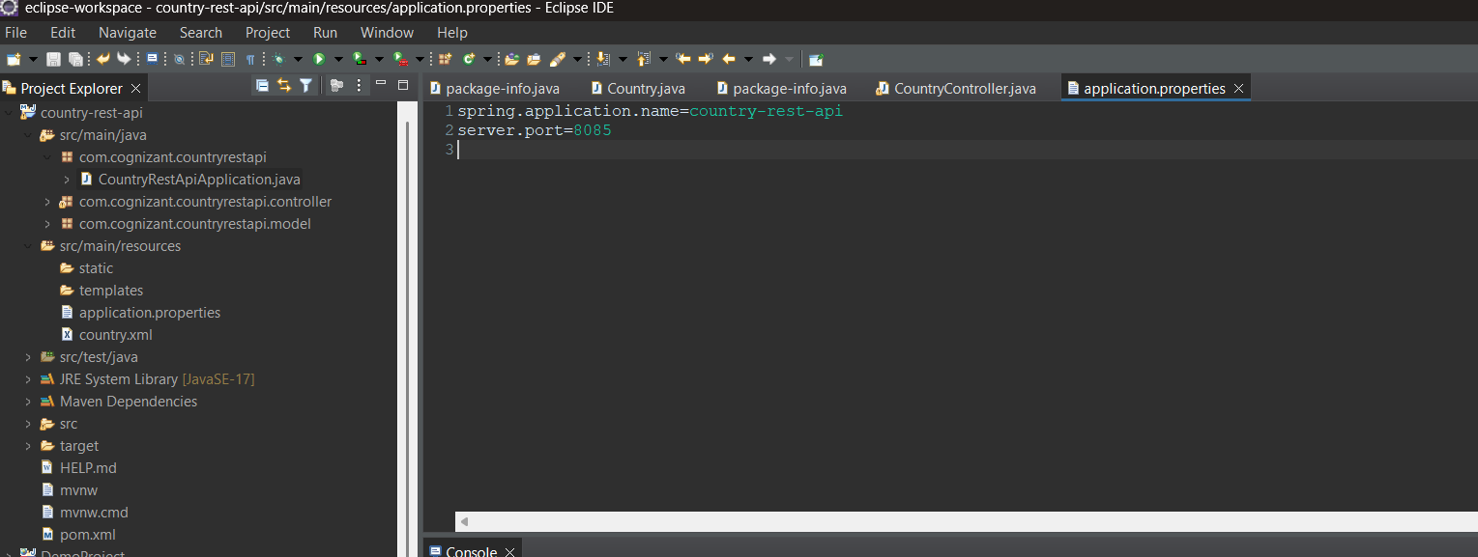

**CountryController.java**

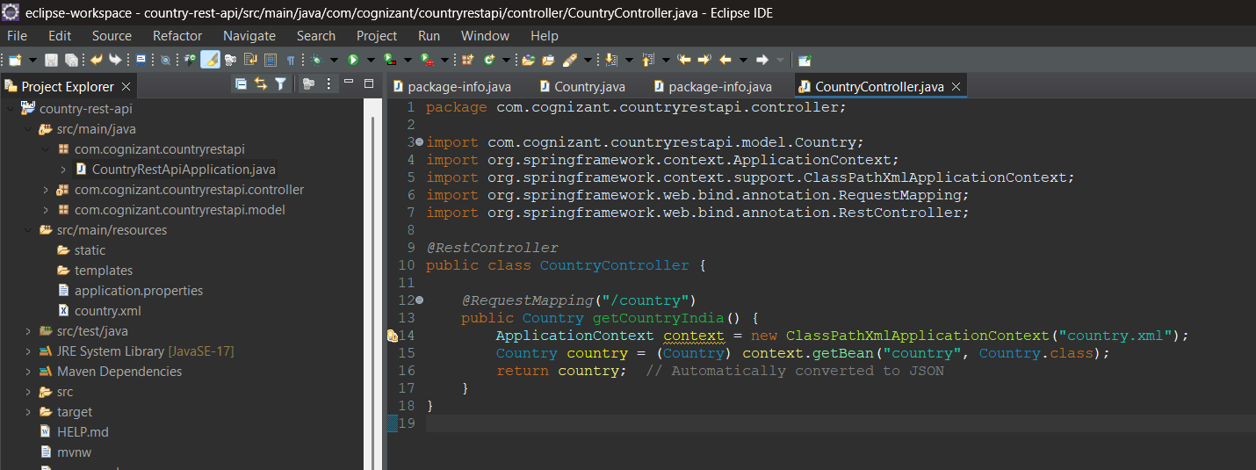

**Country.java**

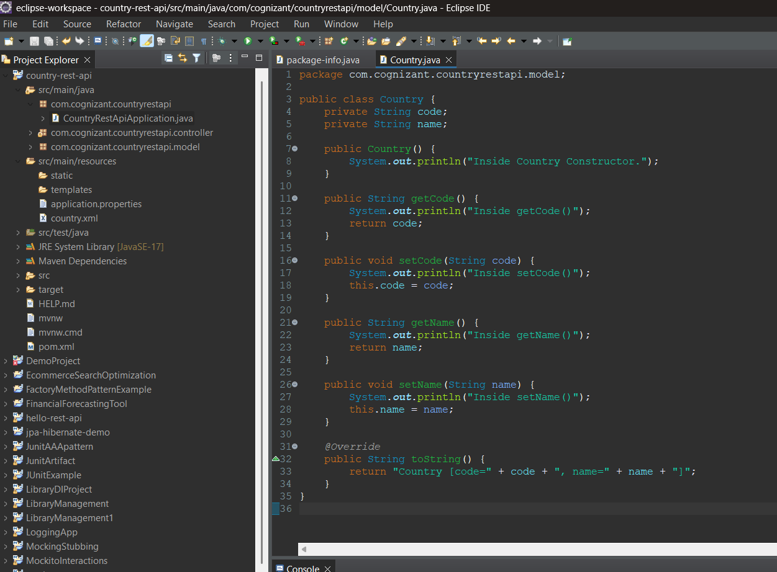**Console**

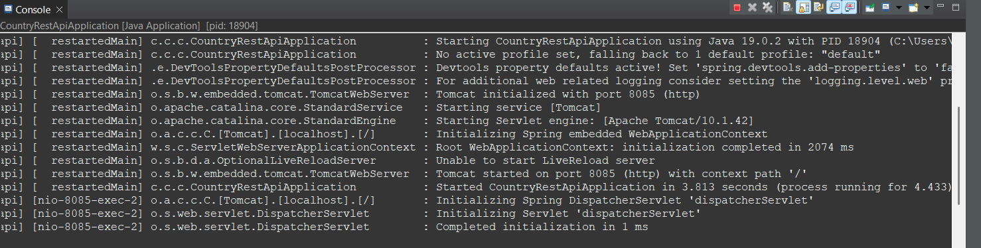

**Postman**

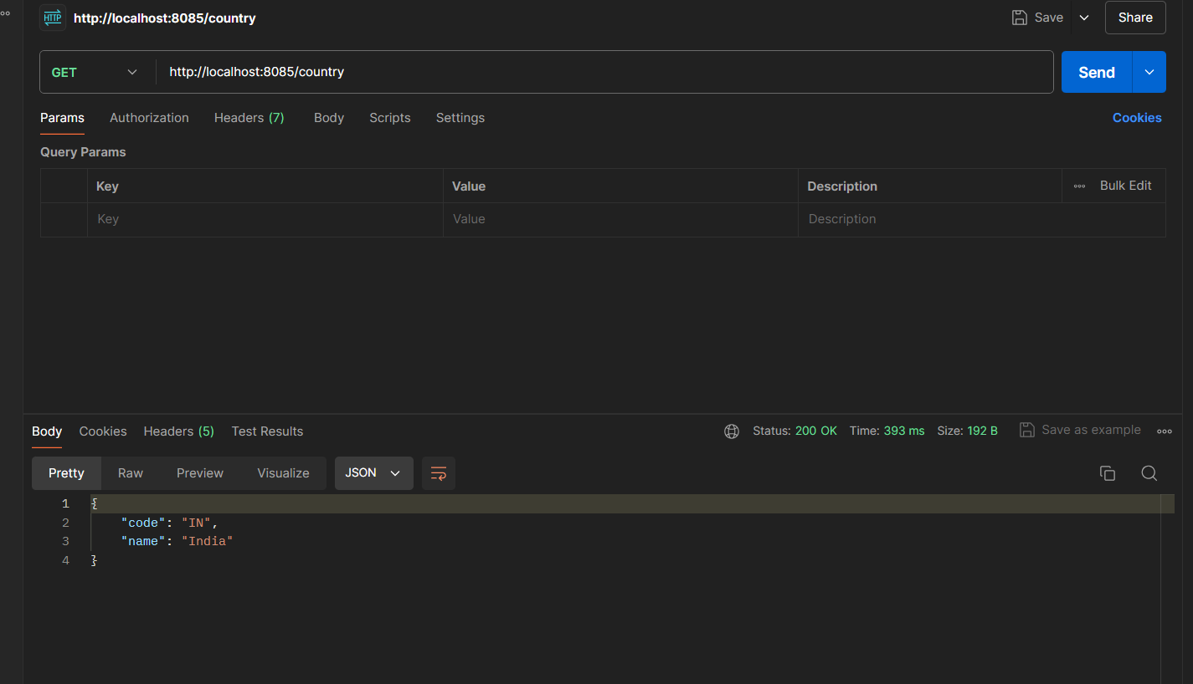

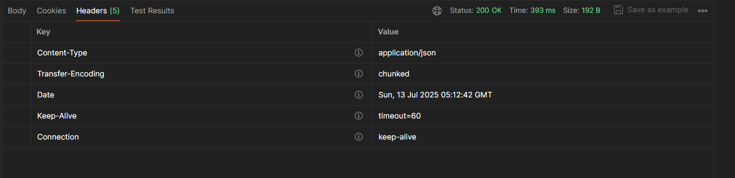

**REST - GET COUNTRY BASED ON COUNTRY CODE**

**Country.xml**

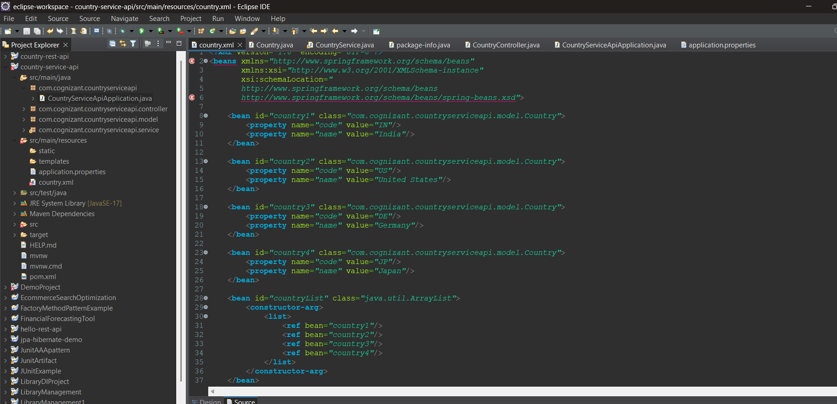

**Application.properties**

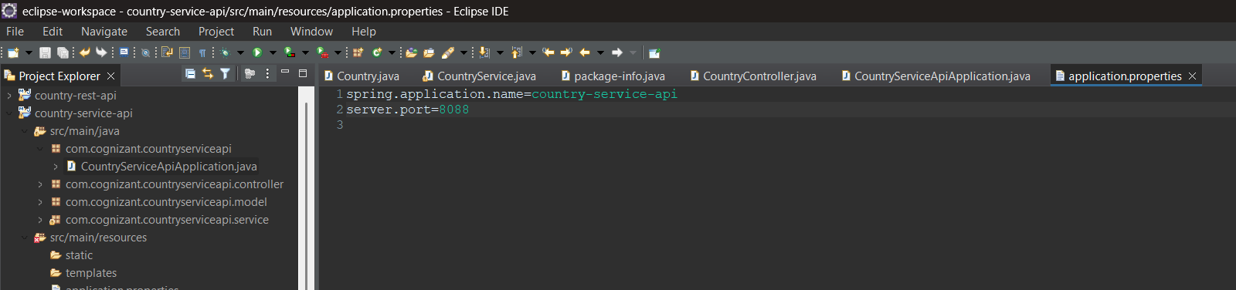

**CountryServiceApiApplication.java**

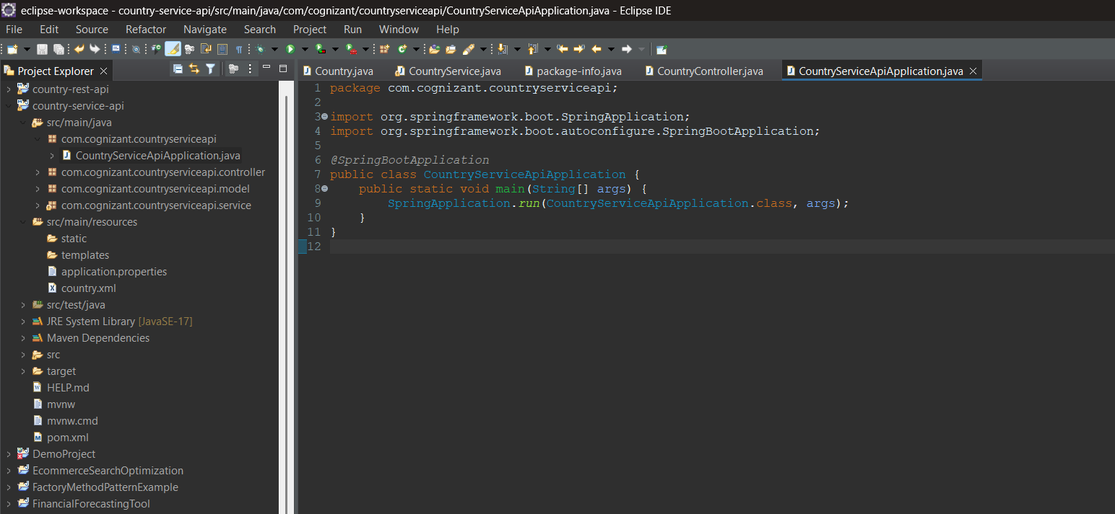

**CountryController.java**

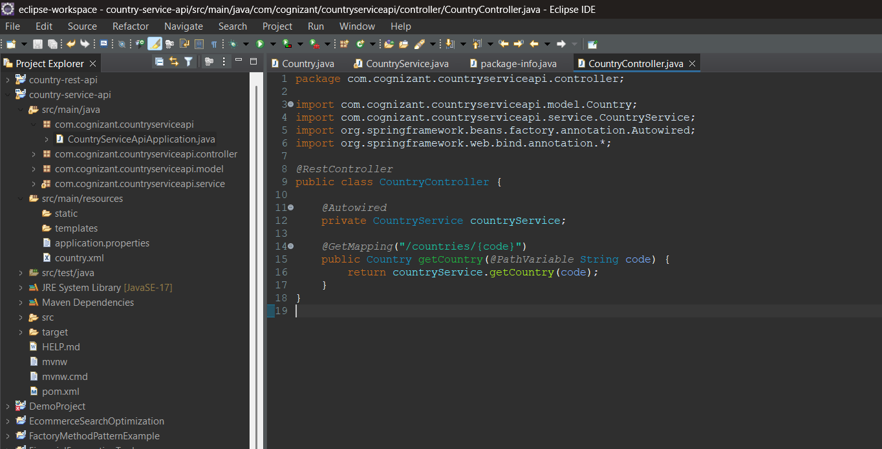

**CountryService.java**

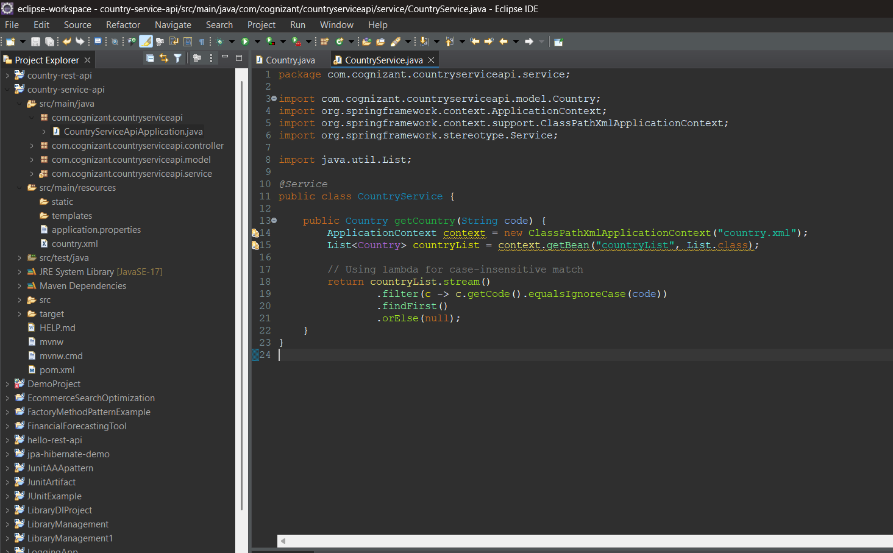

**Country.java**

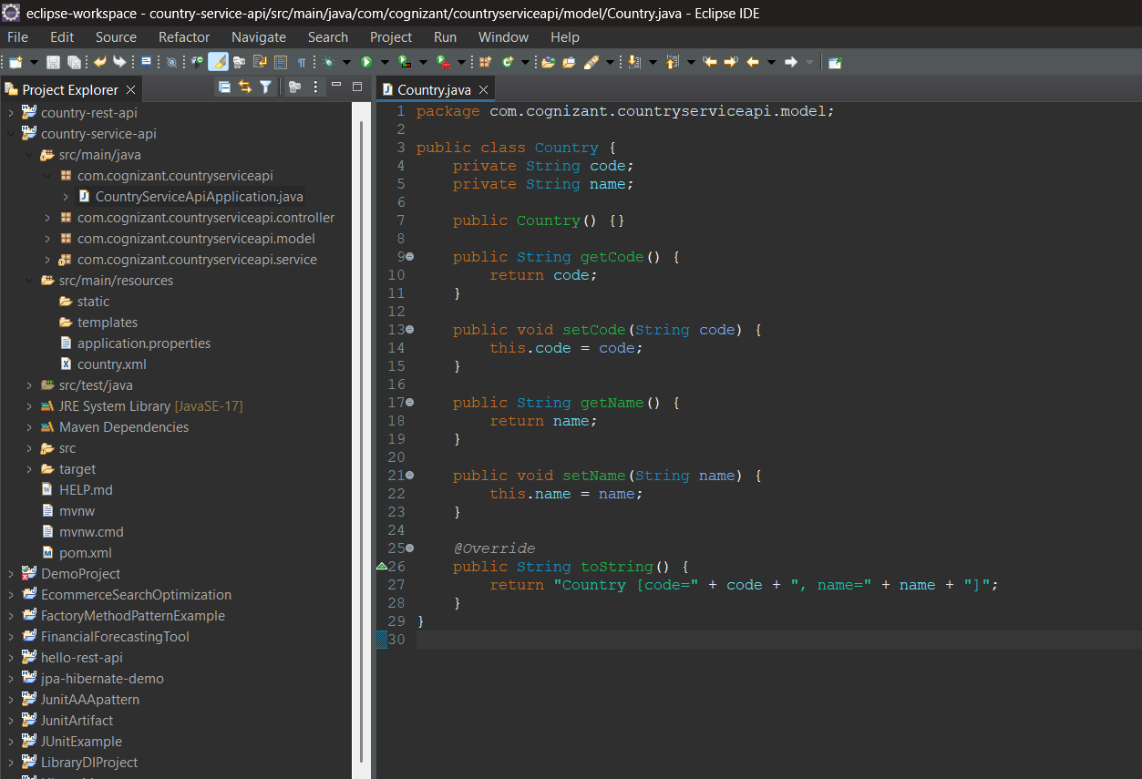

**Console**

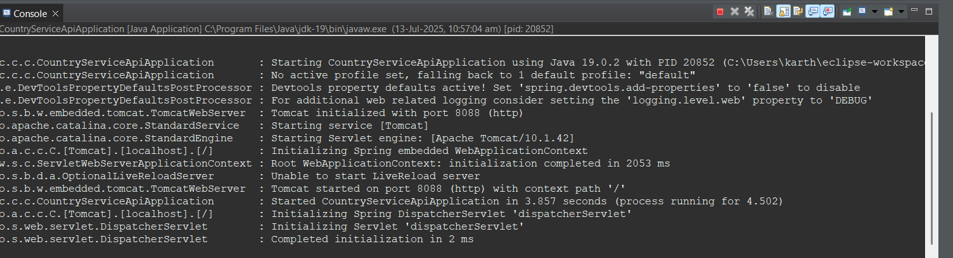

**Postman**

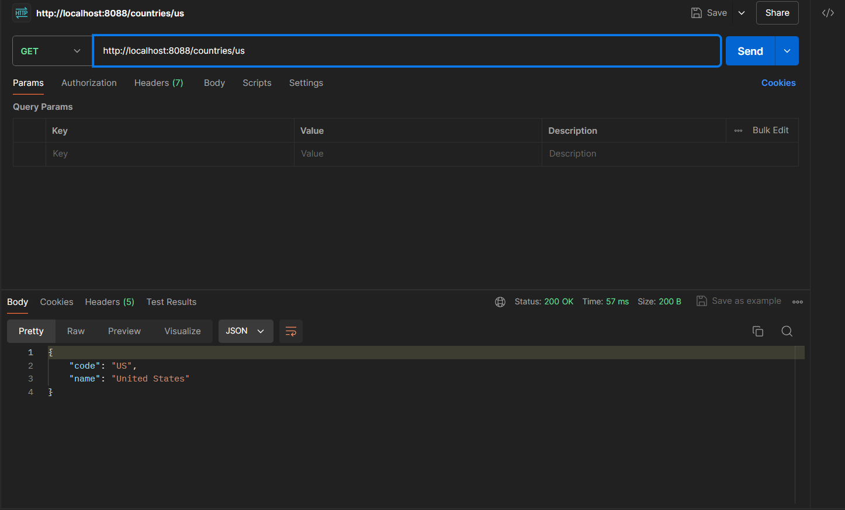

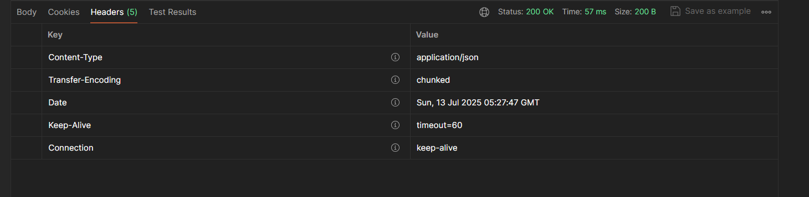

**JWT-HANDSON**

**CREATE AUTHENTICATION SERVICE THAT RETURNS JWT**

**Pom.xml**

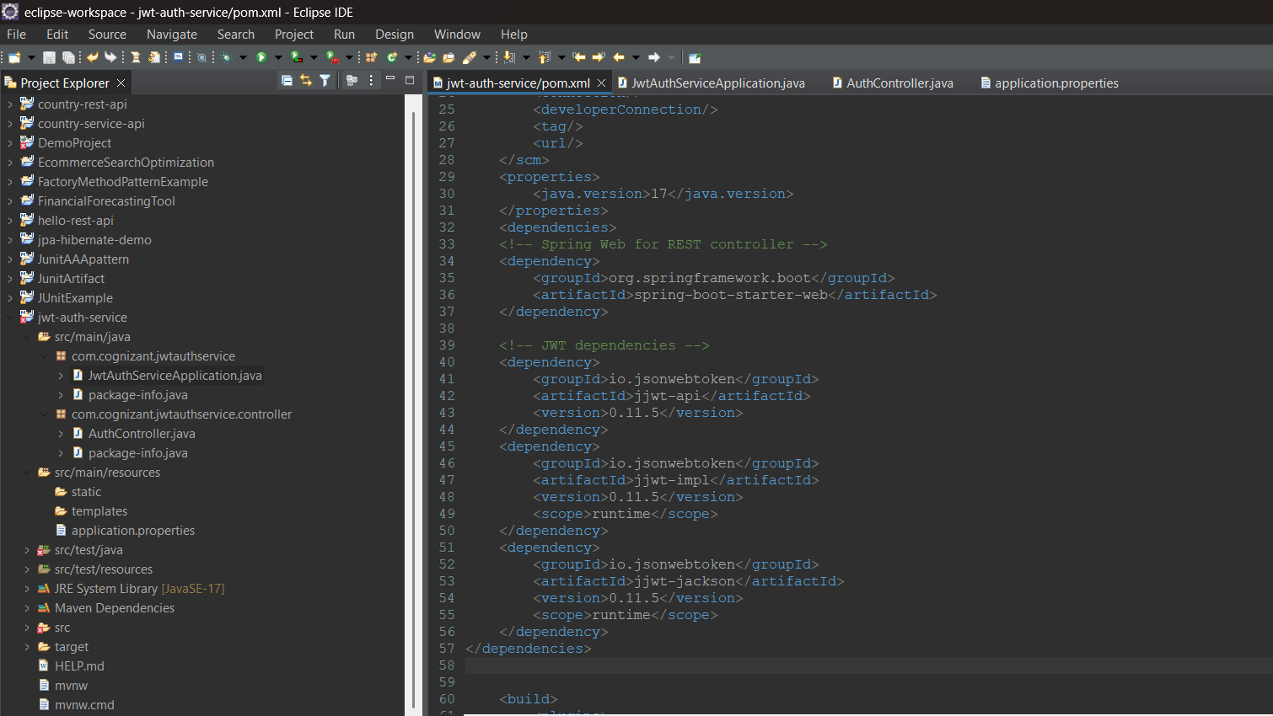

**JwtAuthServiceApplication.java**

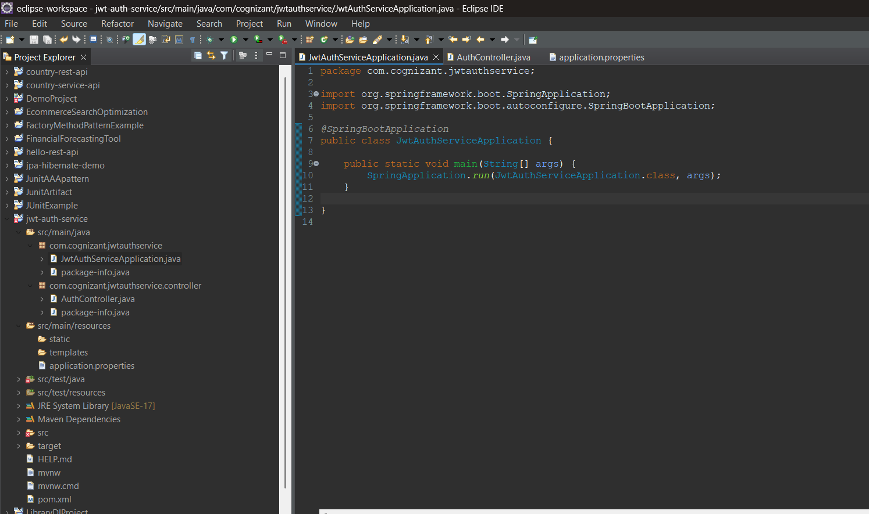

**AuthController.java**

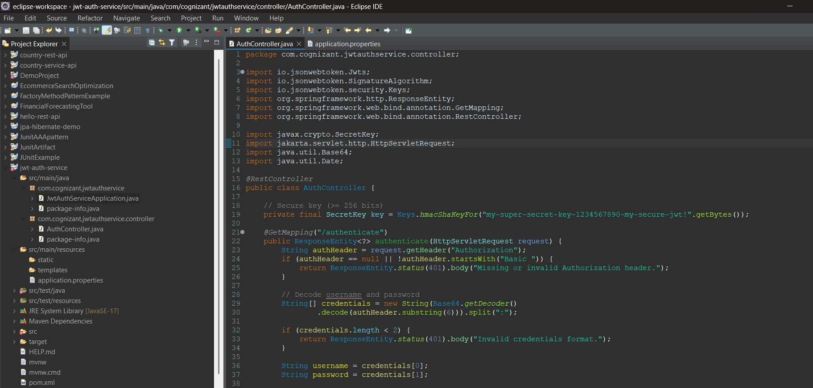

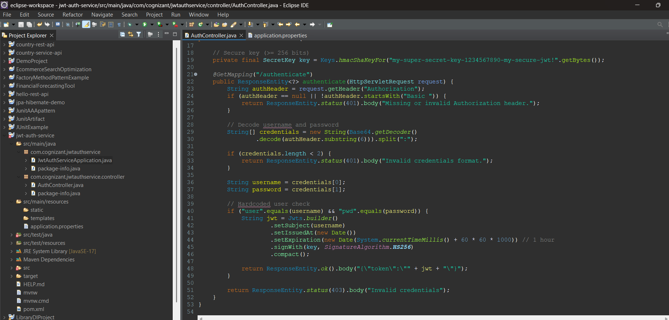

**Application.properties**

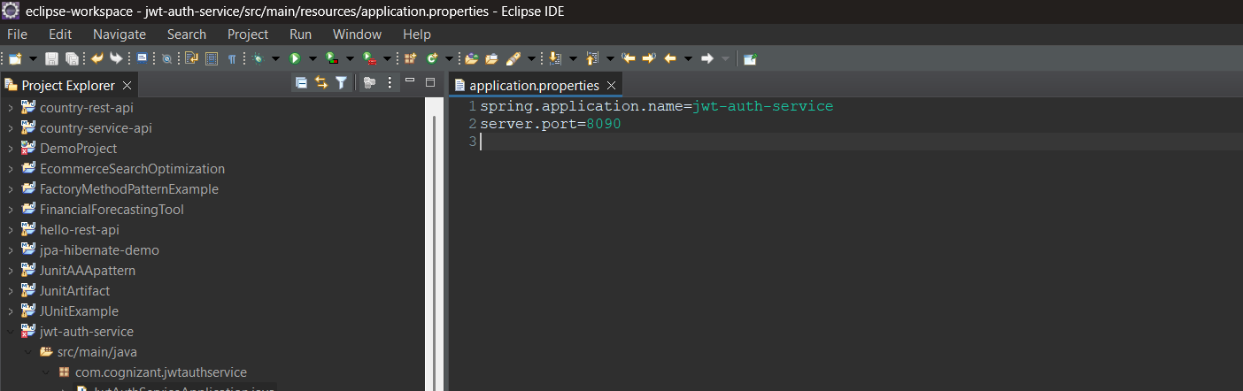

**Console**

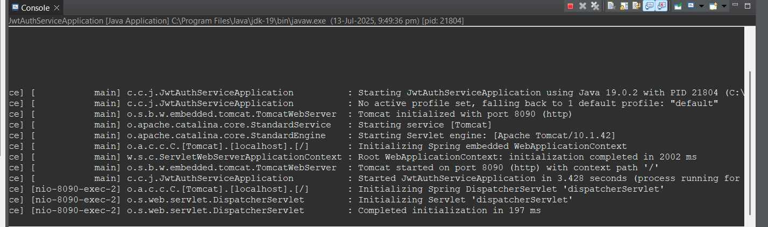

**Postman**

